Tab 1

PROBLEM 1
HINT: “Spot the difference”

- Contestants will be given 2 images as below.
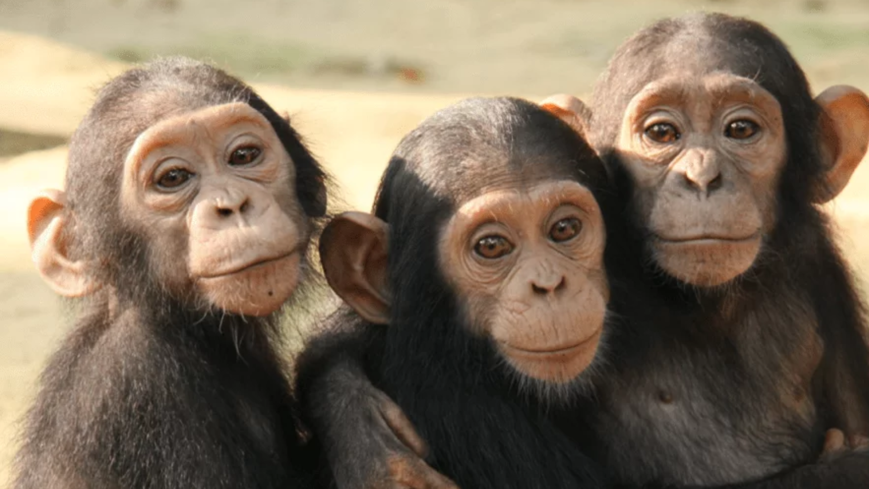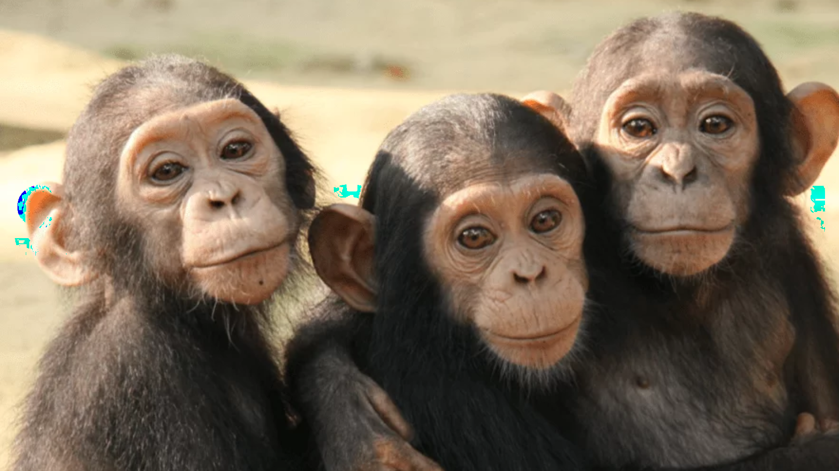

- The key to cracking this task is to notice the slight difference between two images.
- Subtracting the left image from the right will result in an array consisting of 0 and 1 that corresponds to another image.
- Multiplying the result by 255 to show the image on the entire color channel will give the following result which is the solution.

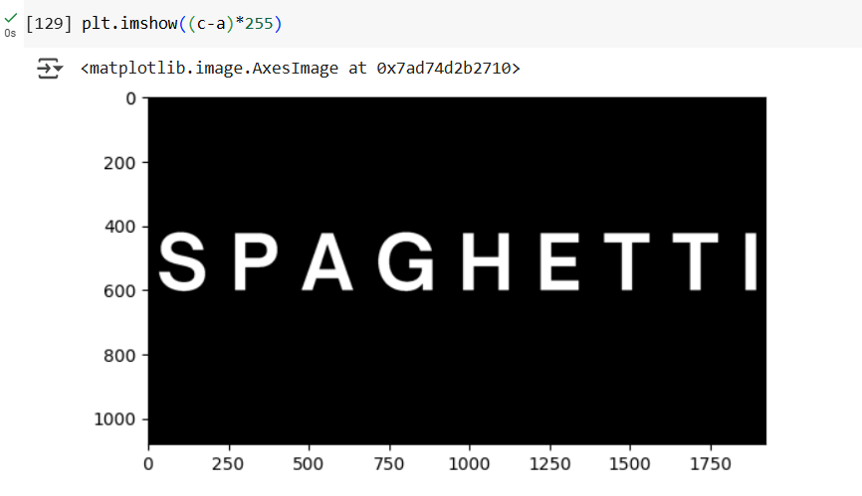
ANSWER: SPAGHETTI

PROBLEM 2
HINT: “Look at the sound”

- Contestants will be given a .wav (audio) file
- To figure out the answer, this audio file must be visualized in a spectrogram. (Is likely to be easily figure out by google search or chat gpt)
- The answer will appear. (using other software without having to code also works)
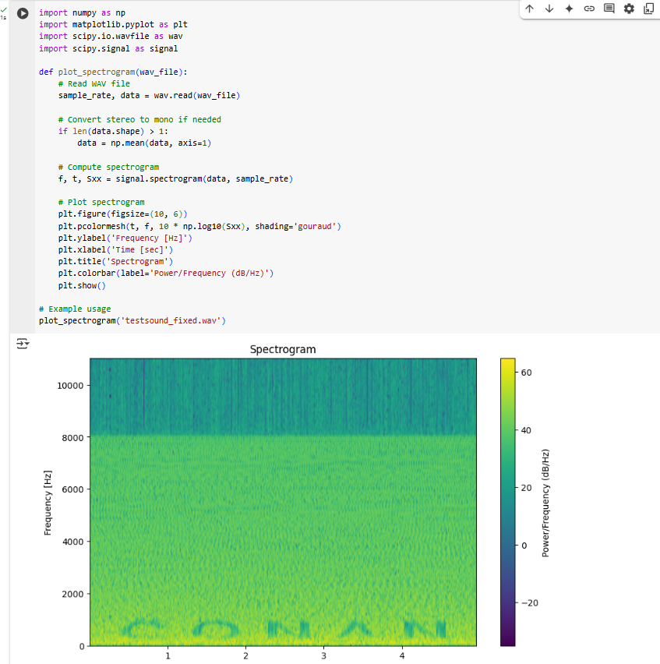
ANSWER: CONAN

PROBLEM 3
HINT: - (too easy)

- Contestants will be given a website: https://int-hack-ctf-inspect-website.vercel.app
- This website is built using HTML, CSS, and JavaScript. The answer is hidden within these 3 associated files (commented). Contestants must inspect all three to find it. 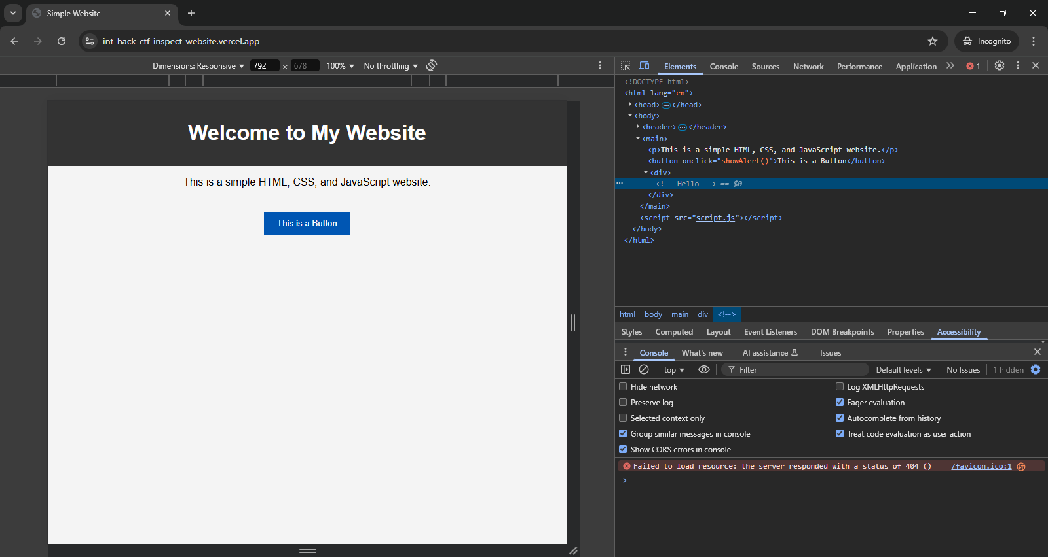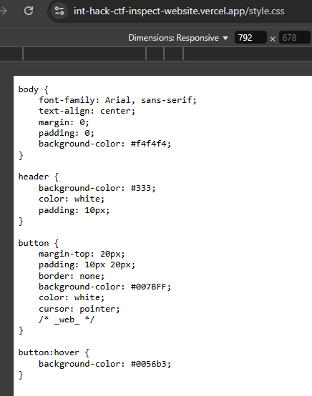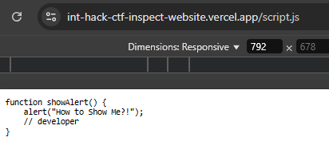

ANSWER: Hello_web_developer

PROBLEM 4
HINT: “Make the square”

- The file given to the contestants will be in .npy format (saved numpy array) of shape 8 rows and 784 columns
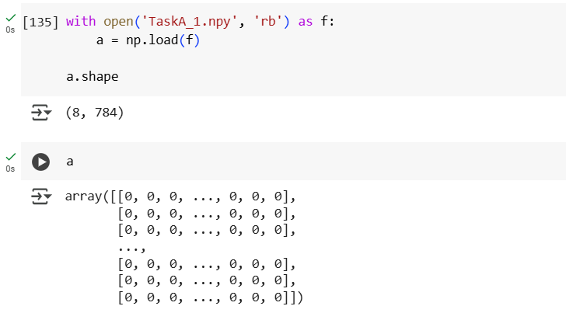

- The key to cracking this task is to realize that the array is the representation of images: each of the 8 rows is a flatten array representation of 28*28 image
- If the data in each row is reshaped into (28, 28) and plotted separately, the numbers will appear. The answer is an 8 digits number from all the rows combined.
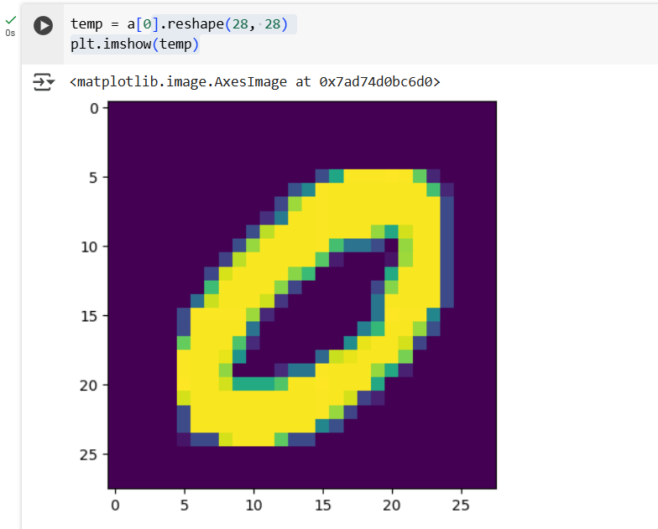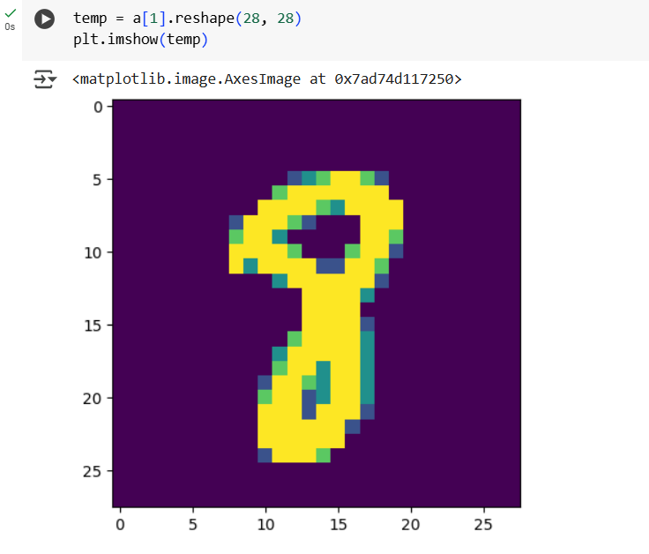

ANSWER: 08937821

PROBLEM 5
HINT: HTTP

- Contestants will be given a website: https://int-hack-ctf-http.onrender.com 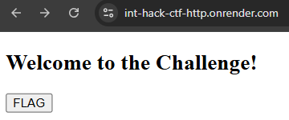
- By clicking the FLAG button, it redirects to https://int-hack-ctf-http.onrender.com/flag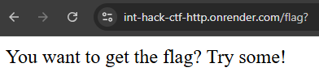
- The key of this message is that by clicking the button, you are trying to GET the flag (with a GET request). You'll need more effort than (with a POST request).
- To reveal the flag, a POST request must be sent instead of GET, for example, by curl: curl -X POST https://int-hack-ctf-http.onrender.com/flag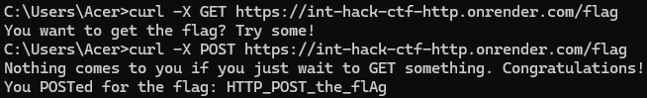
or by Postman: 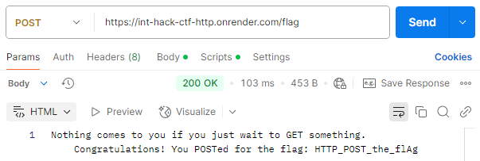

ANSWER: HTTP_POST_the_flAg

PROBLEM 6
HINT1: XOR
HINT2: Capture the FLAG

- Contestants will be given a file FLAG.bin
- .bin stores data in binary format, which can be read using the "rb" mode.
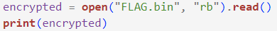
- To decrypt the data, XOR decryption is applied, and the key is unknown, requiring a brute-force approach. Since this is a ‘Capture The Flag’ challenge and given the 'FLAG' in the filename, ‘FLAG’ is detectable within the decrypted content.
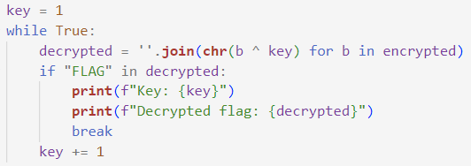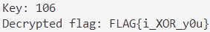

ANSWER: i_XOR_y0u

PROBLEM 7
HINT: “Sometimes, the least significant bit carries the most meaning.”

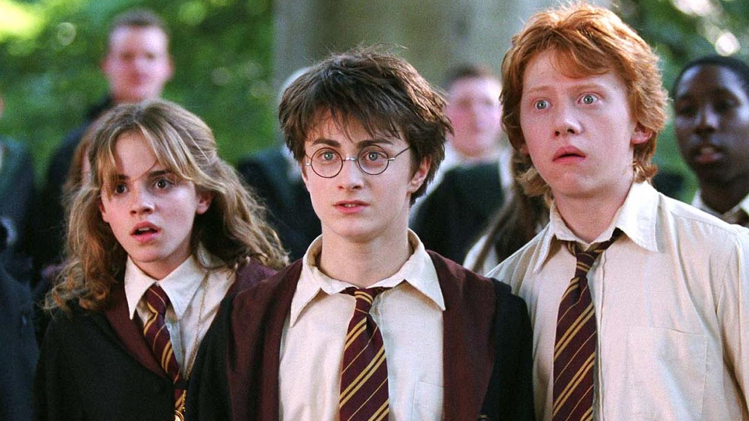
- Contestants will be given a .png file

- LSB is a technique that encodes binary data into the last bits of each pixel in the image; this can be decoded by getting the last bits of pixel value from the image.
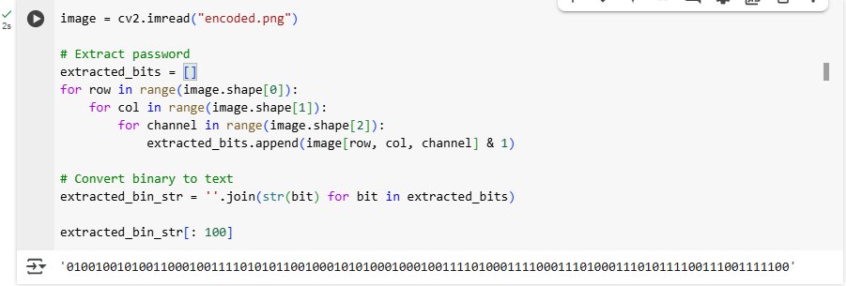

- The first 64 bits can be translated into text as: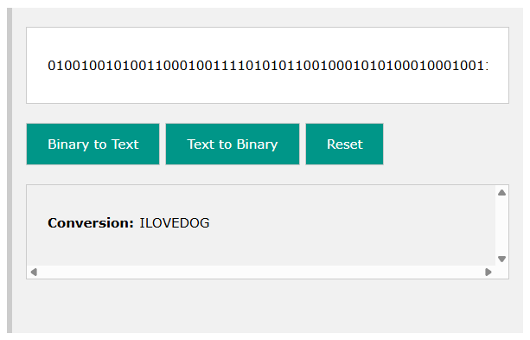

ANSWER: ILOVEDOG

PROBLEM 8
HINT: “Too many dimensions?”
- Contestants will be given a csv file as follows:
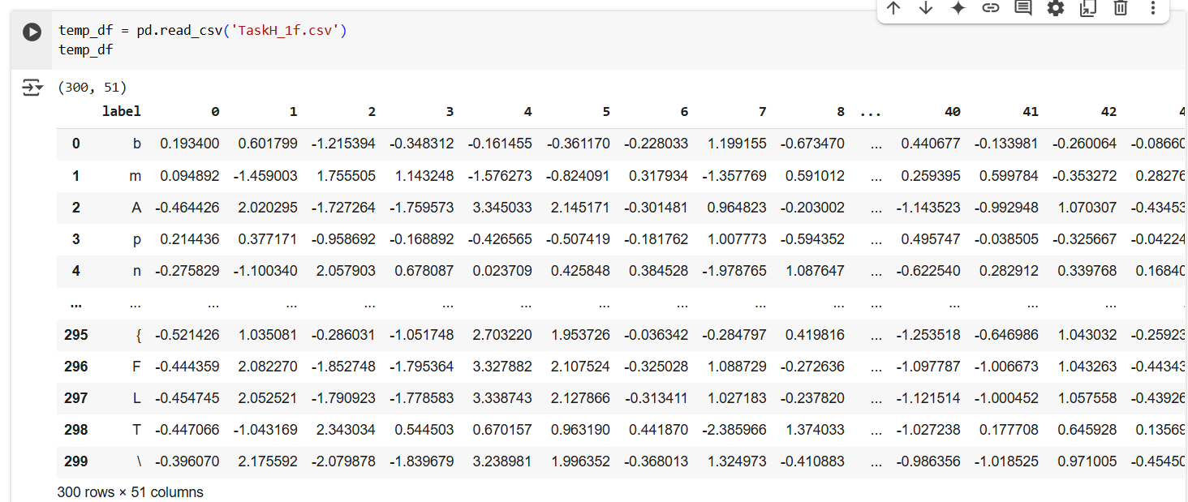
- The solution is to perform dimensionality reduction on the given dataset to reduce the dimension to 2. This can be done by Principal Component Analysis (PCA).
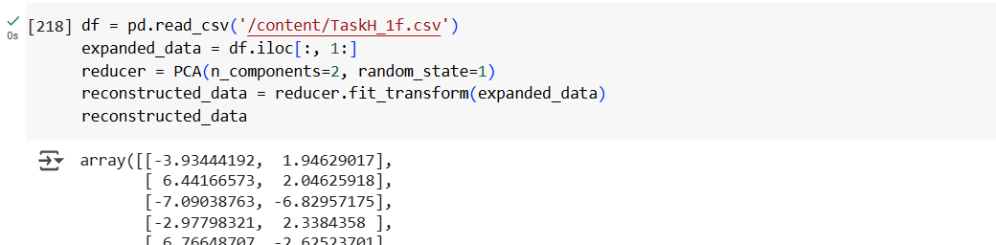
- Now each row refers to the x and y coordinate of the symbol in the label column. When the symbols are plotted to their corresponding coordinates, this will appear (see bottom left of the heart);
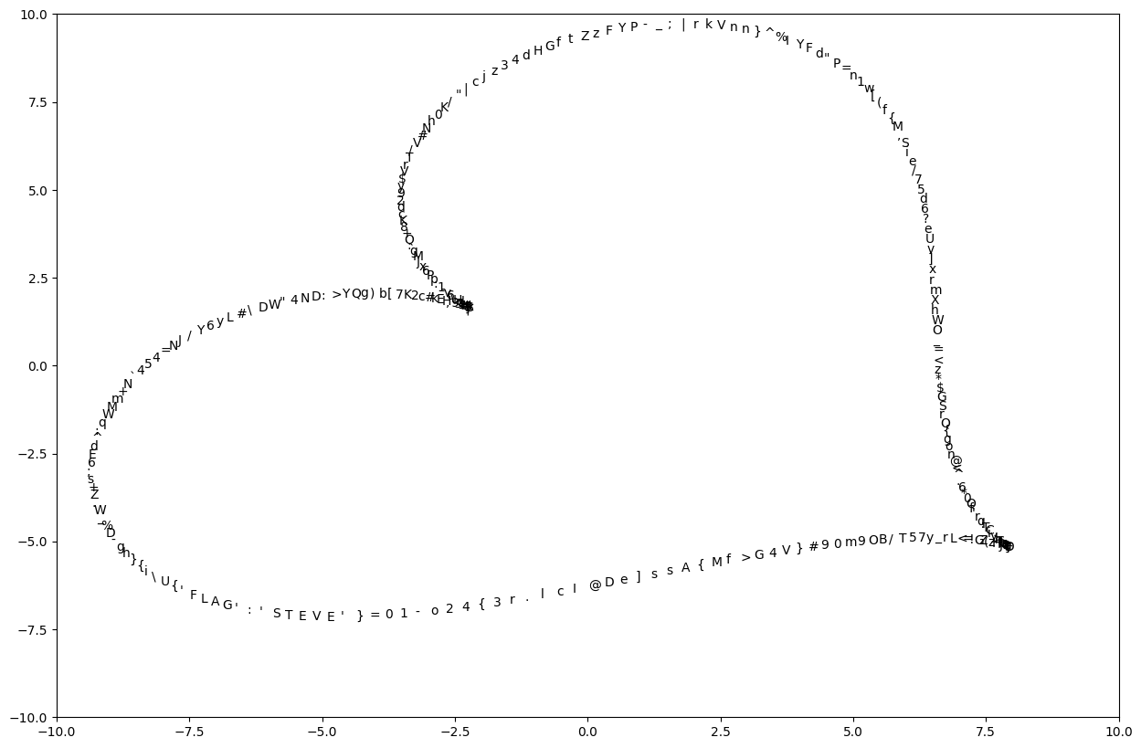
ANSWER: STEVE

